

**Batch: B–1 Roll No.: 16010422234 Experiment No.: 01**

**_____________________________________________________________________________**

**Aim:** Virtualization using VMware workstation and XEN Server-Client installation

**_____________________________________________________________________________**

**Resources needed:** VMWare Setup, XEN installation set up

**_____________________________________________________________________________**

**Pre–Requisite:** Understanding of Installation of Operating System

**_____________________________________________________________________________**



**Theory:**

**Concept of Virtualization**

Virtualization addresses IT’s most pressing challenge: the infrastructure sprawl that compels IT departments to channel 70 percent of their budget into maintenance, leaving scant resources for business-building innovation.

The difficulty stems from the architecture of today’s X86 computers: they’re designed to run just one operating system and application at a time. As a result, even small data centers have to deploy many servers, each operating at just five percent to 15 percent of capacity—highly inefficient by any standard.

Virtualization software solves the problem by enabling several operating systems and applications to run on one physical server or “host”. Each self-contained “virtual machine” is isolated from the others, and uses as much of the host’s computing resources as it requires.

**Advantages of virtualization**

* Run multiple operating systems on one server. For example, instead of having development-server and QA-server, you can run both development and QA on a single server.
* You can have multiple flavours of OS on one server. For example, you can run 2 Linux OS, 1 Windows OS on a single server.
* Multiple OS running on the server shares the hardware resources among them. For example, CPU, RAM, network devices are shared among development-servers and QA-servers running on the same hardware.
* Allocate hardware resources to different applications based on the utilization. For example, if you have 8GB of RAM on the server, you can assign less RAM to one virtual machine (2GB to development-server) and more RAM (6GB to QA-server) to another virtual machine that is running on that server.
* High availability and business continuity. If VMware is implemented properly, you can migrate a virtual machine from one server to another server quickly without any downtime.
* This reduces the operational cost and power consumption. For example, instead of buying and running two servers, you will be using only one server and run both development and QA on it.

**VMware**

VMware is a [virtualization a](http://searchservervirtualization.techtarget.com/definition/virtualization)nd [cloud computing s](http://searchcloudcomputing.techtarget.com/definition/cloud-computing)oftware provider for [x86](http://searchwinit.techtarget.com/definition/x86)-compatible computers. VMware Inc. is a subsidiary of EMC Corporation and has its headquarters in Palo Alto, California. VMware Workstation makes it possible to partition a single physical [server](http://whatis.techtarget.com/definition/server) [i](http://whatis.techtarget.com/definition/server)nto multiple virtual machines. VMware workstation works with [Windows,](http://searchwindowsserver.techtarget.com/definition/Windows) [Solaris,](http://searchenterpriselinux.techtarget.com/definition/Solaris) [Linux a](http://searchenterpriselinux.techtarget.com/definition/Solaris)nd [Netware,](http://searchnetworking.techtarget.com/definition/NetWare) any or all of which can be used concurrently on the same [hardware.](http://searchcio-midmarket.techtarget.com/definition/hardware)

**Xen**

Xen is a Virtual Machine Monitor (VMM) also known as a hypervisor; this is a software system that allows the execution of multiple virtual guest operating systems simultaneously on a single physical machine. Xen is known as a Type 1 or “bare-metal” hypervisor, meaning that it runs directly on top of the physical machine as opposed to within an operating system. Guest virtual machines running on Xen are known as “domains” and a special domain known as dom0 is responsible for controlling the hypervisor and starting other guest operating systems. These other guest operating systems are called domUs, this is because these domains are “unprivileged” in the sense they cannot control Xen or start/stop other domains.

Xen supports 2 primary types of virtualization, para-virtualization and hardware virtual machine (HVM) also known as “full virtualization”. Para-virtualization uses modified guest operating systems that we refer to as enlightened guests. These operating systems are aware that they are being virtualized and as such don’t require virtual “hardware” devices, instead they make special calls to Xen that allow them to access CPUs, storage and network resources.

In contrast HVM guests need not be modified as Xen will create a fully virtual set of hardware devices for this machine that resemble a physical x86 computer. This emulation requires much more overhead than the paravirtualization approach but allows unmodified guest operating systems like Microsoft Windows to run on top of Xen. HVM support requires special CPU extensions - VT-x for Intel processors and AMD-V for AMD based machines. This technology is now prevalent and all recent servers and desktop systems should be equipped with them.

**XEN Architecture**

The Xen hypervisor runs directly on the hardware and is responsible for handling CPU, Memory, and interrupts. It is the first program running after exiting the bootloader. On top of Xen we can run a number of virtual machines. A running instance of a virtual machine in Xen is called a domain or guest. A special domain, called domain 0 contains the drivers for all the devices in the system. Stack to manage virtual machine creation, destruction, and configuration.

* **Guest Domains/Virtual Machines** are virtualized environments, each running their own operating system and applications. Xen supports two different virtualization modes: Paravirtualization (PV) and Hardware-assisted or Full Virtualization (HVM). Both guest types can be used at the same time on a single Xen system. It is also possible to use techniques used for Paravirtualization in an HVM guest: essentially creating a continuum between PV and HVM. This approach is called PV on HVM. Xen guests are totally isolated from the hardware: in other words, they have no privilege to access hardware or I/O functionality. Thus, they are also called unprivileged domain (or DomU).

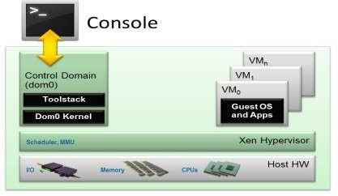

**XEN Architecture**

* **The Control Domain (or Domain 0)** is a specialized Virtual Machine that has special privileges like the capability to access the hardware directly, handles all access to the system’s I/O functions and interacts with the other Virtual Machines. It also exposes a control interface to the outside world, through which the system is controlled. The Xen hypervisor is not usable without Domain 0, which is the first VM started by the system.
* **Toolstack and Console**: Domain 0 contains a control stack (also called Toolstack) that allows a user to manage virtual machine creation, destruction, and configuration. The toolstack exposes an interface that is either driven by a command line console, by a graphical interface or by a cloud orchestration stack such as OpenStack or CloudStack.
* **Xen-enabled operating systems**: A Xen Domain 0 requires a Xen-enabled kernel. Paravirtualized guests require a PV-enabled kernel. Linux distributions that are based on recent Linux kernels are Xen-enabled and usually contain packages that contain the Xen Hypervisor and Tools Xen (the default Toolstack and Console). All but legacy Linux kernels are PV-enable

**_____________________________________________________________________________**

**Procedure:**

1. Download the setup file of VMWare workstation from

[https://www.vmware.com/in/download/open_source.html](http://www.vmware.com/in/download/open_source.html)

1. Install VMware Server using VMware Installation Wizard
2. Download ISO file Xen server 6.2 and Xen Center from

[https://www.citrix.com/downloads/citrix-hypervisor/product-software/xenserver-70-standard-edition.html](http://www.citrix.com/downloads/citrix-hypervisor/product-software/xenserver-70-)

<http://downloadns.citrix.com.edgesuite.net/11653/XenServer-7.0.0-install-cd.iso>

1. Add a Xen server as a VM in VM workstation.
2. Add Xen Center as a VM in VM workstation.
3. Connect Xen server in Xen Center

**_____________________________________________________________________________**

**Results: (Steps with screenshots)**

**Prepare a document with all Steps with screenshots**

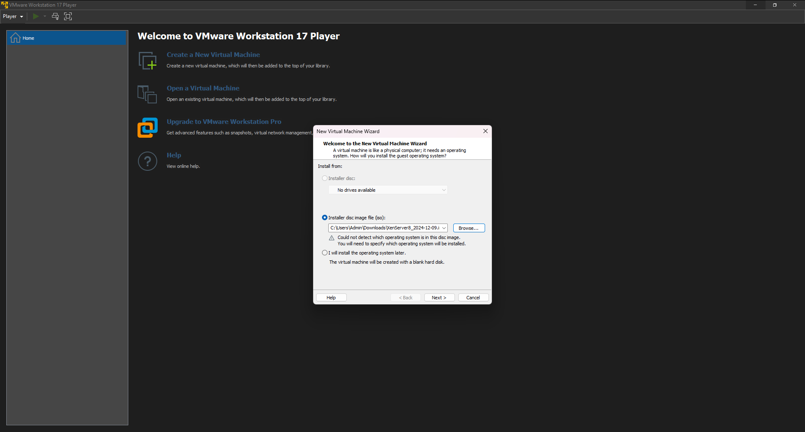

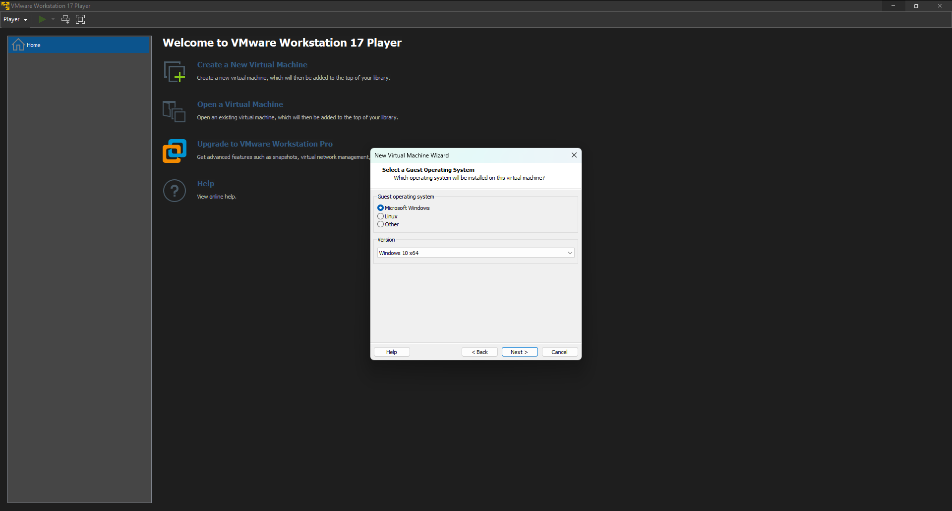

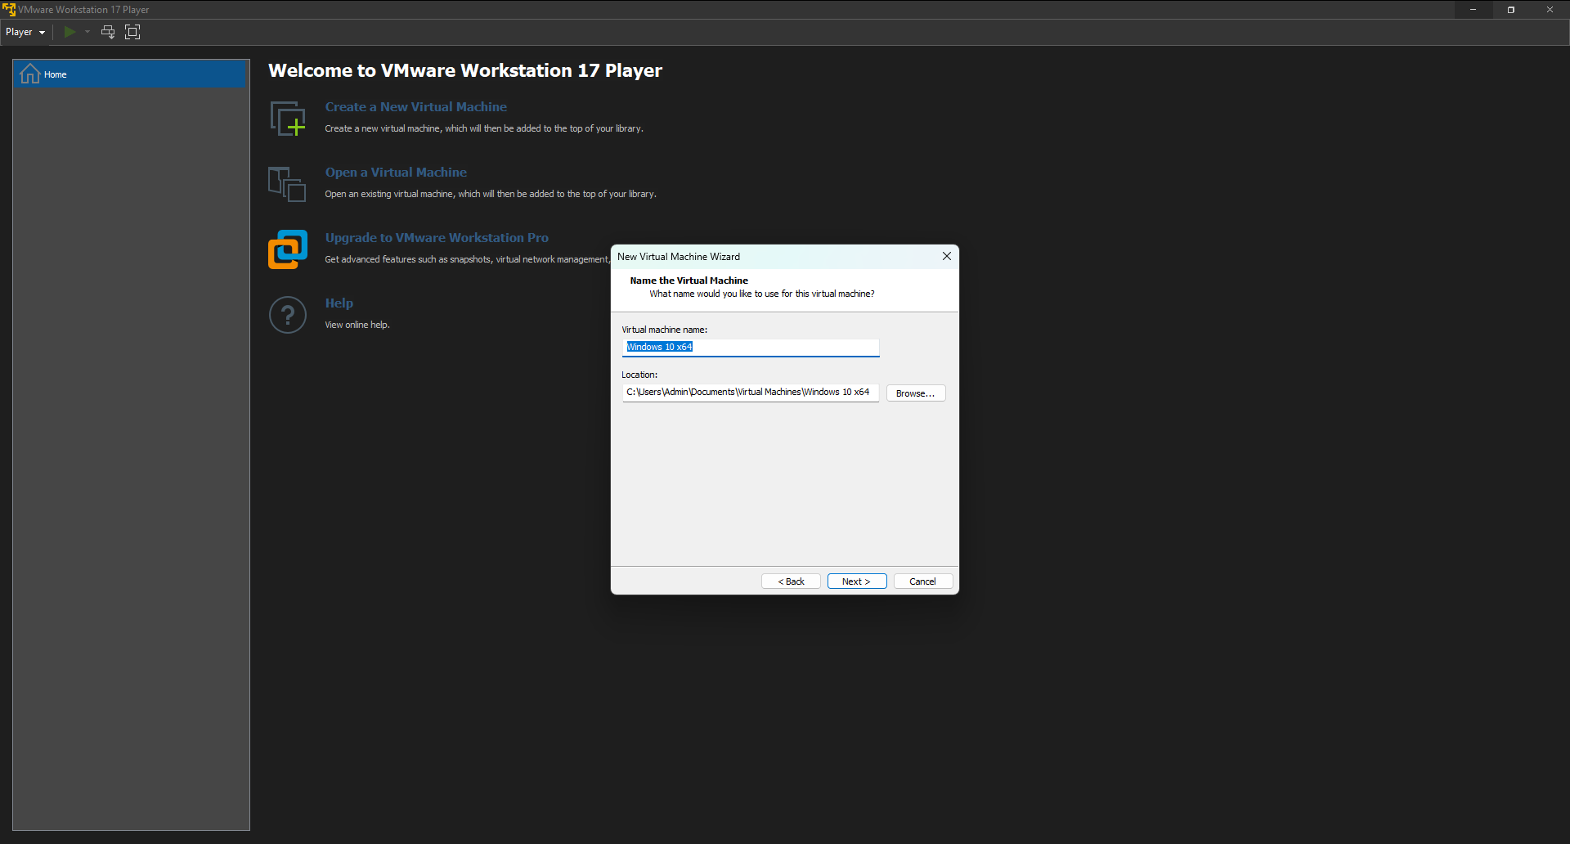

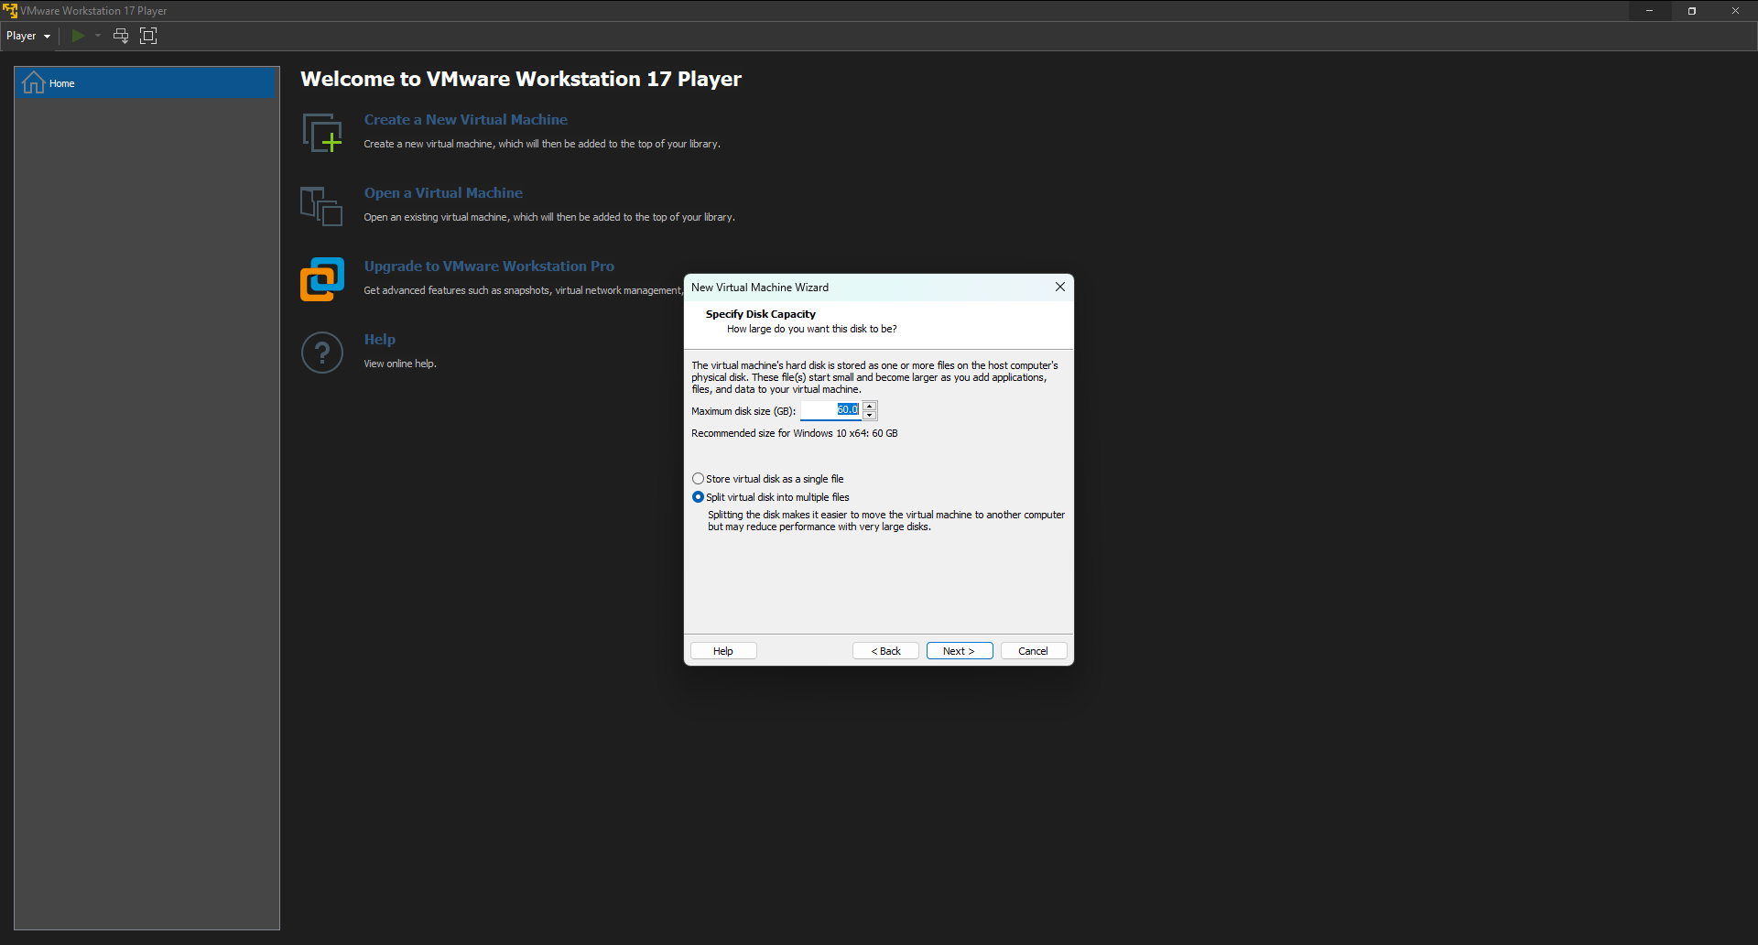

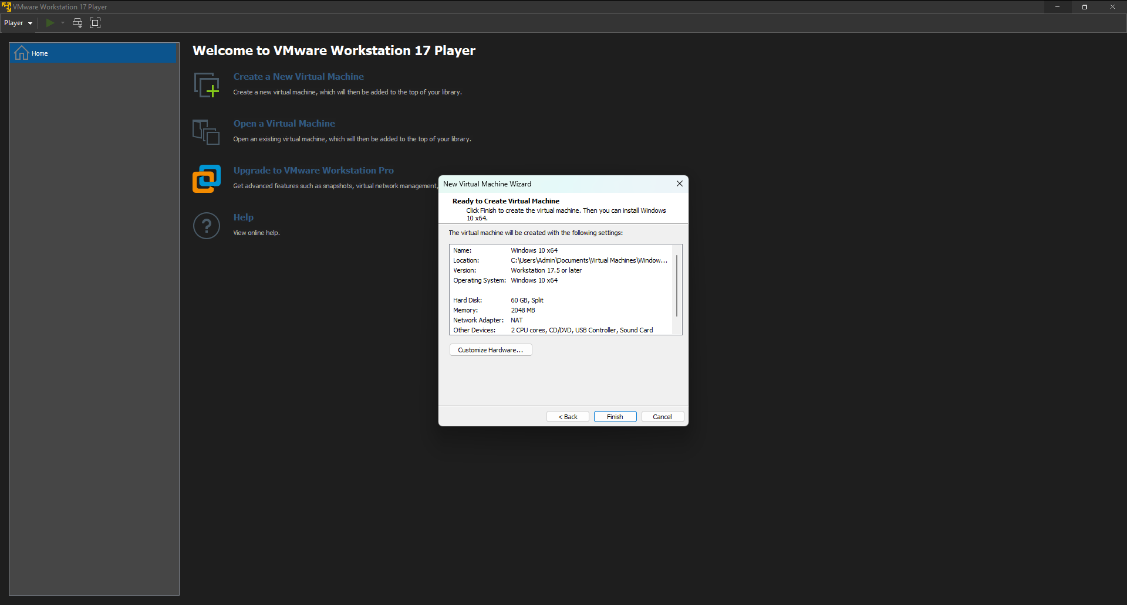

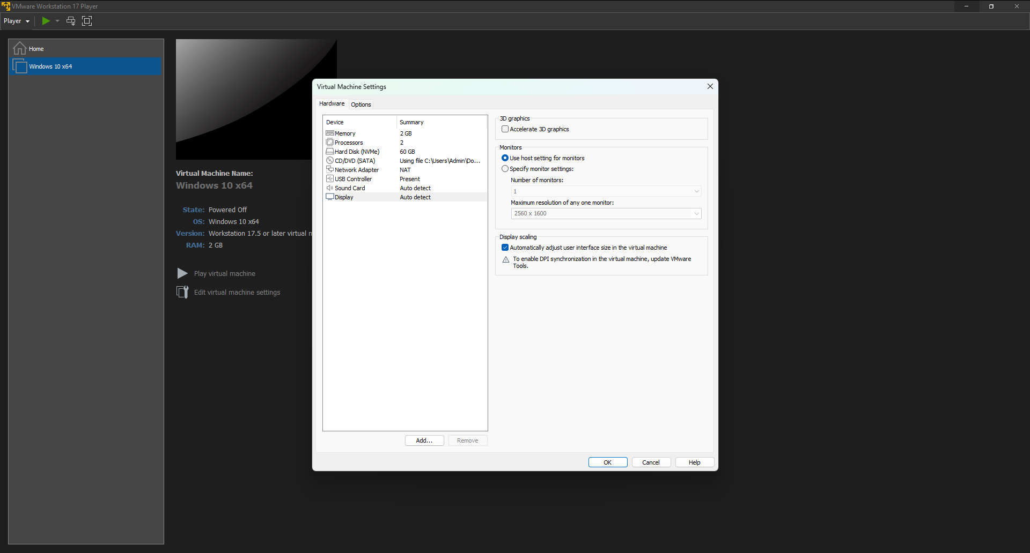

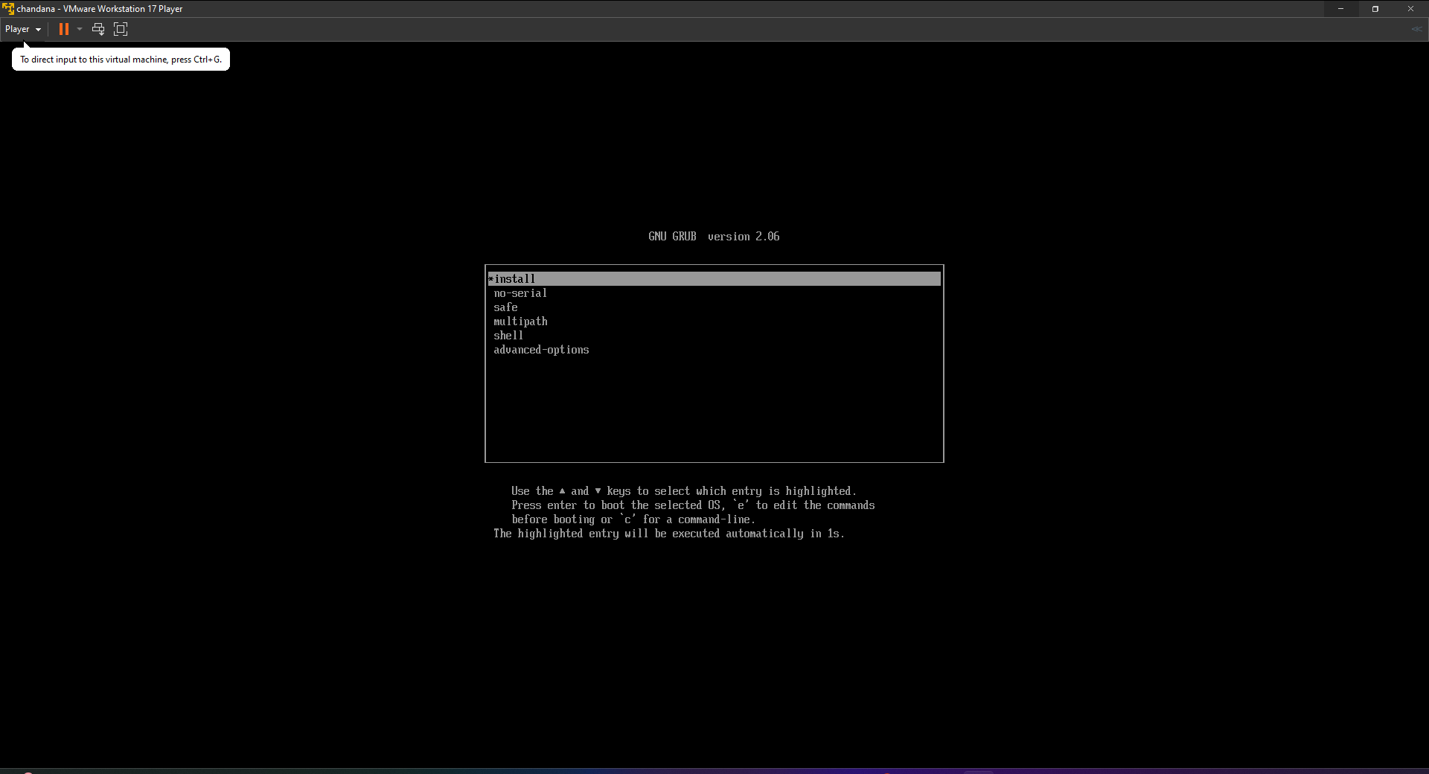

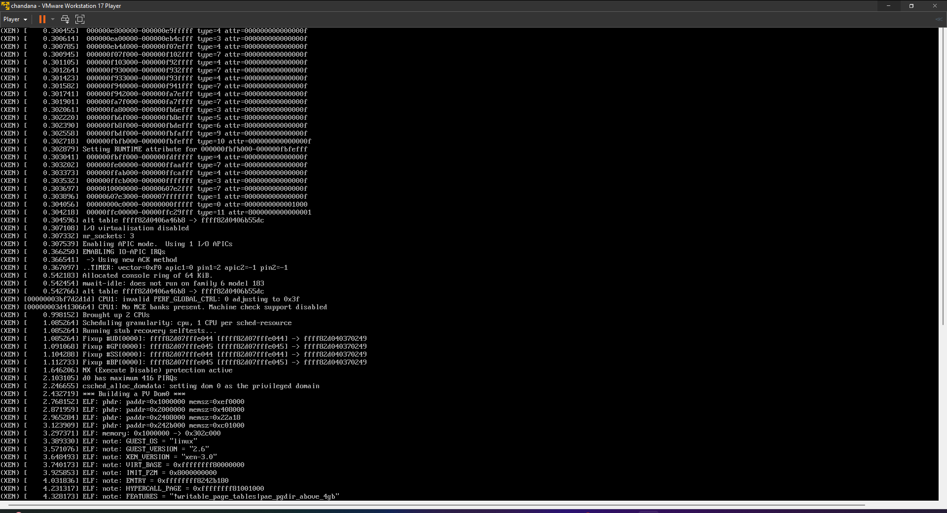

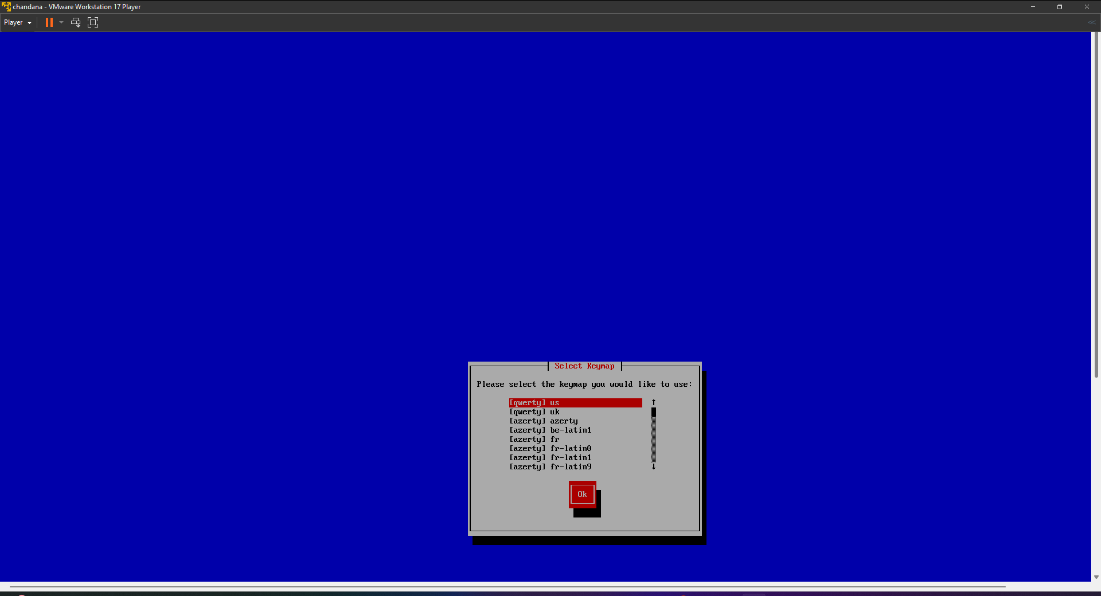

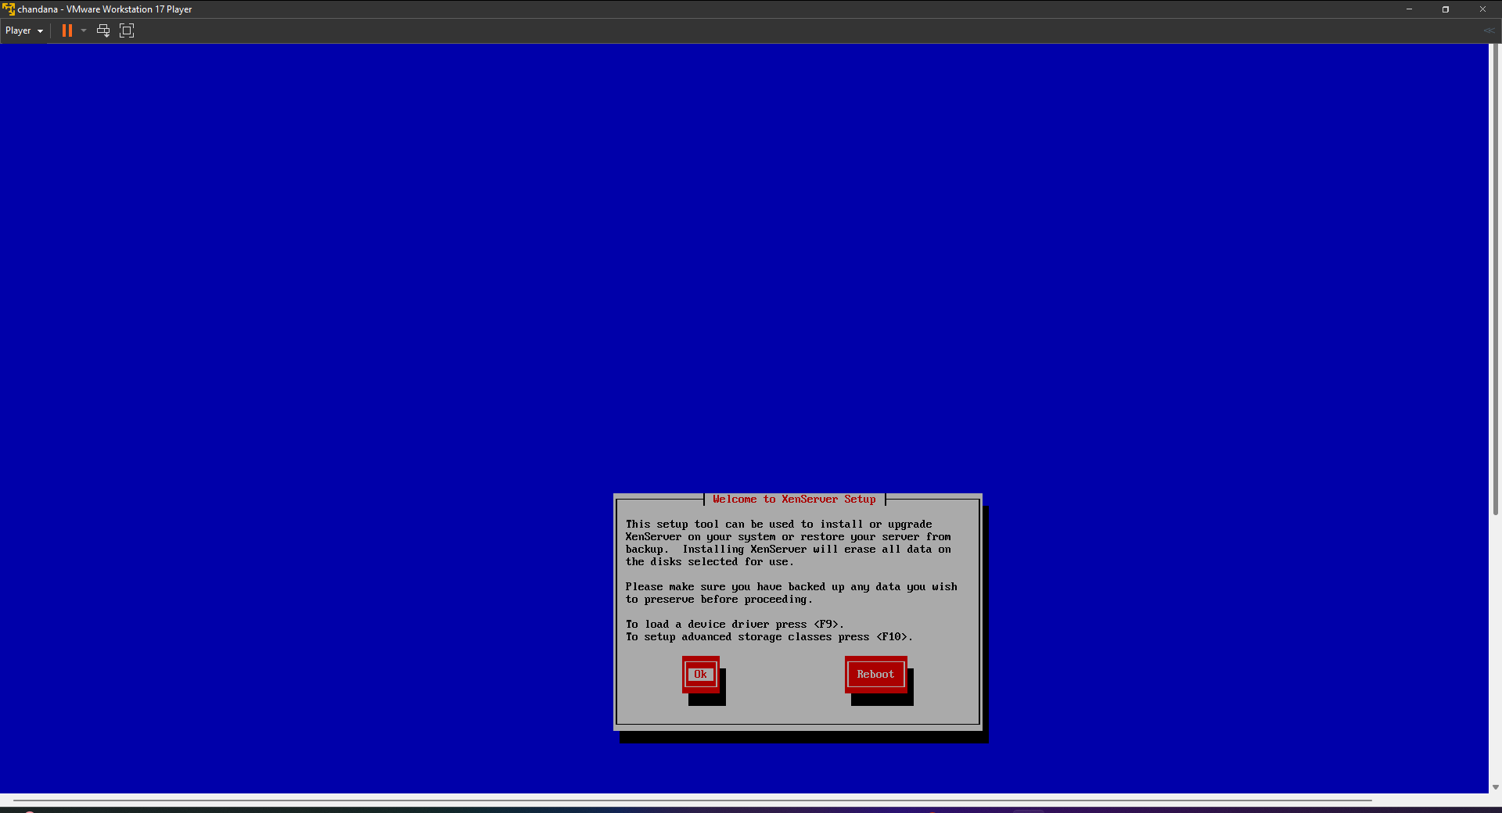

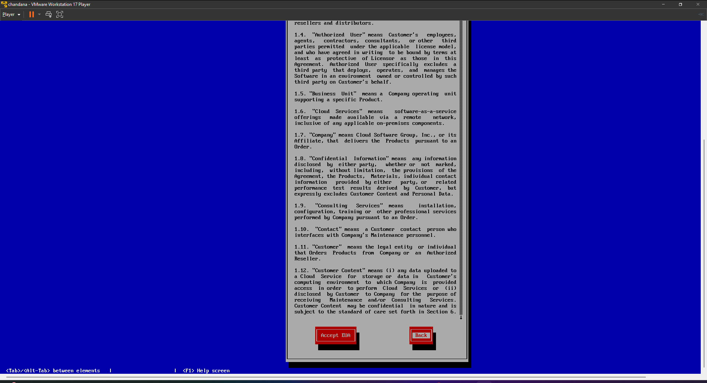

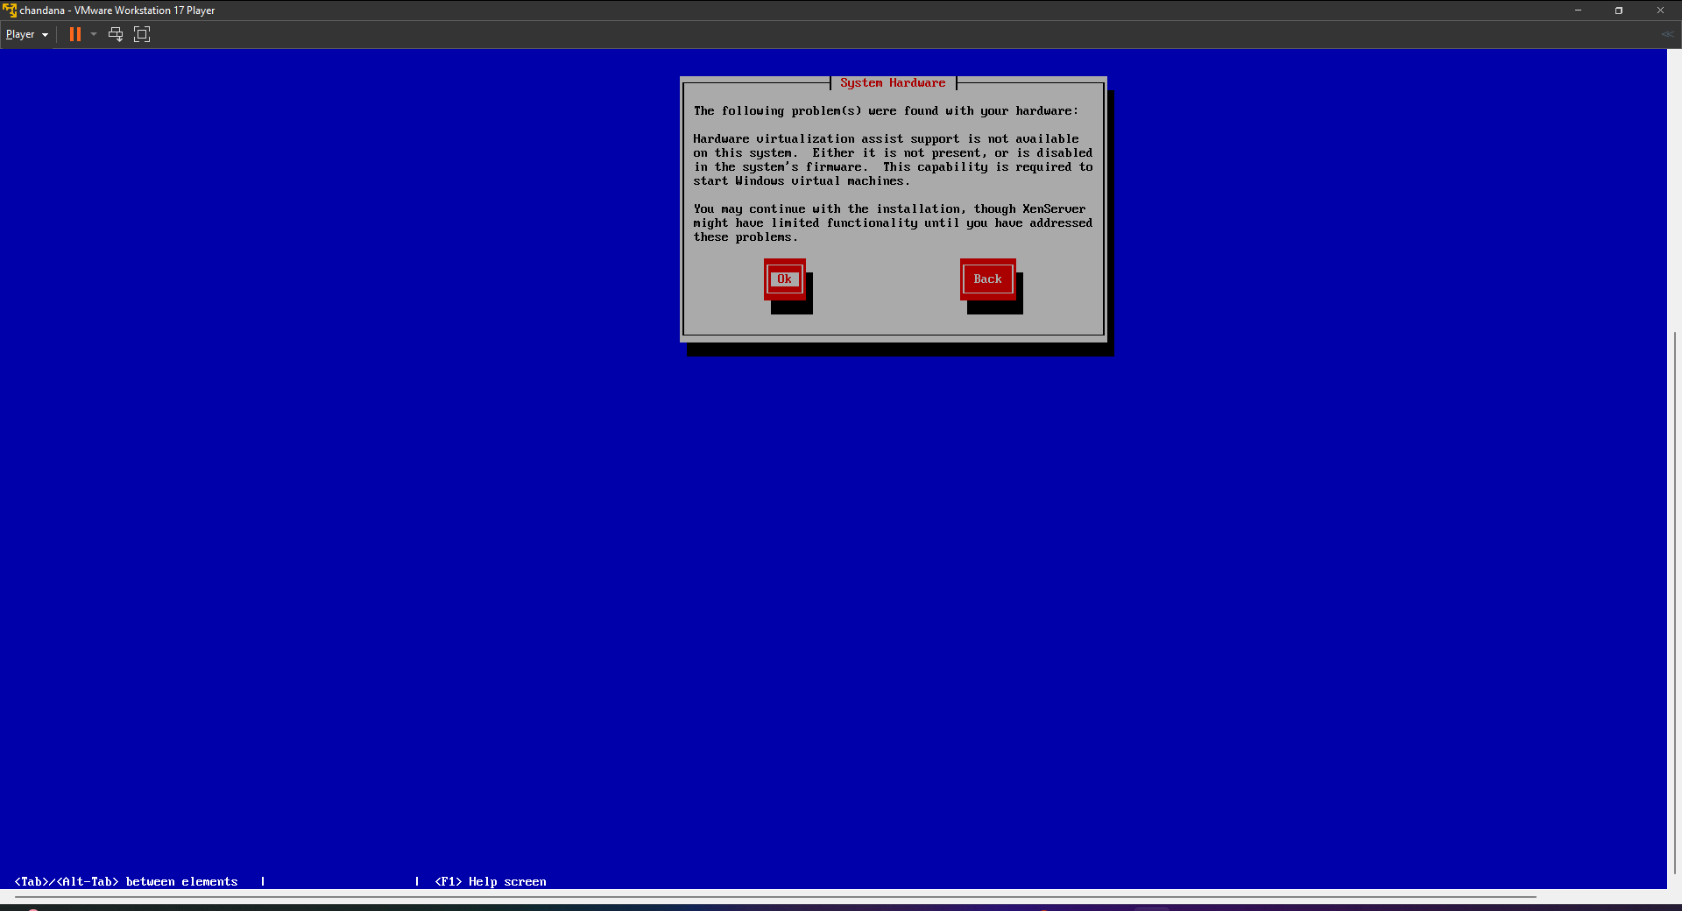

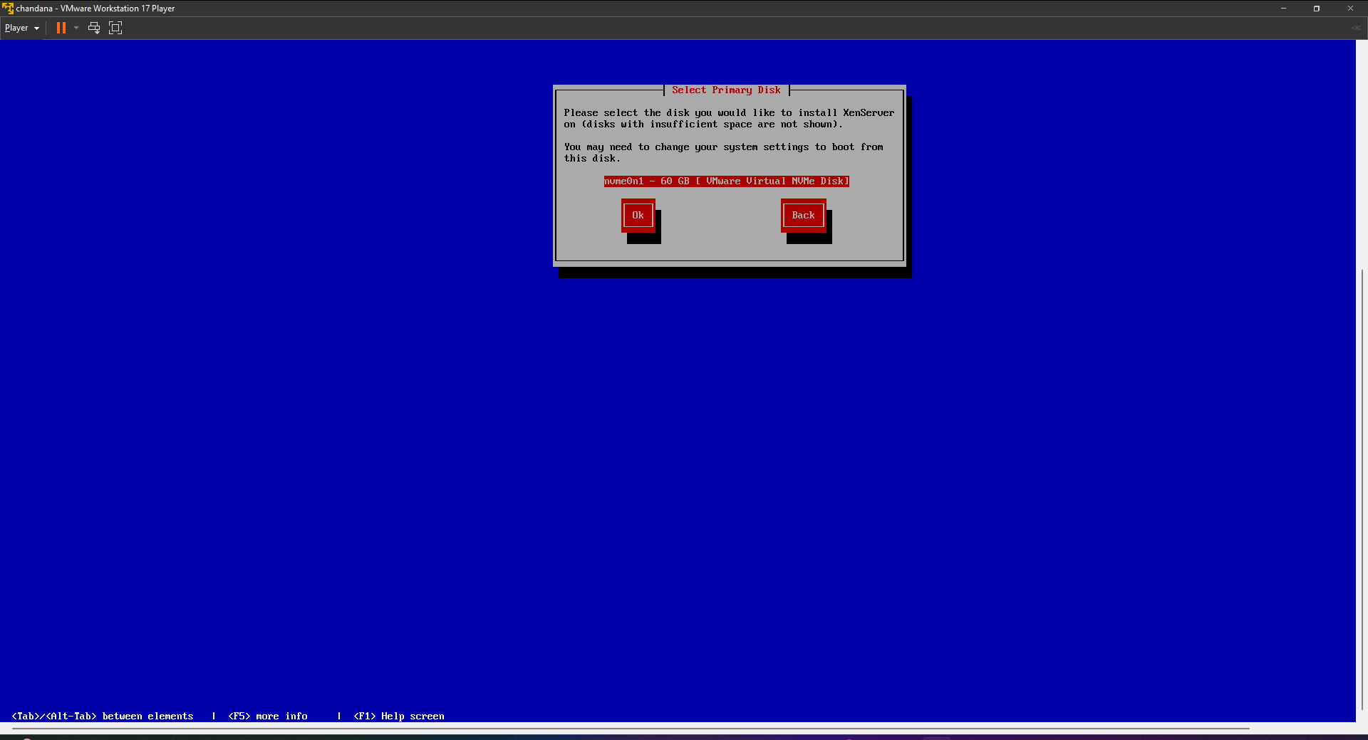

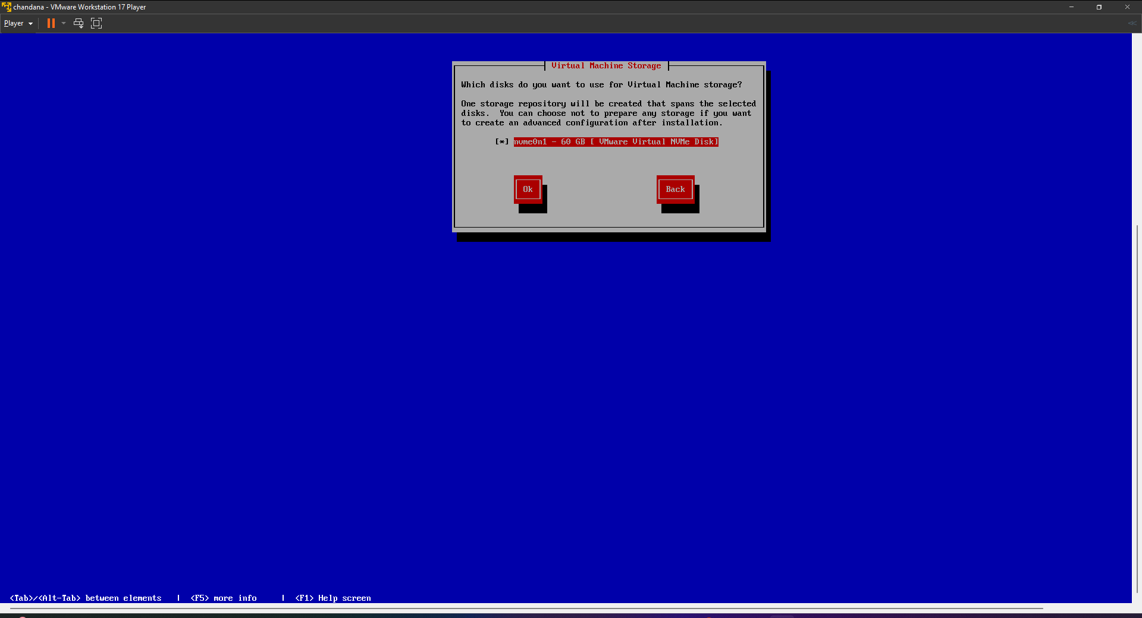

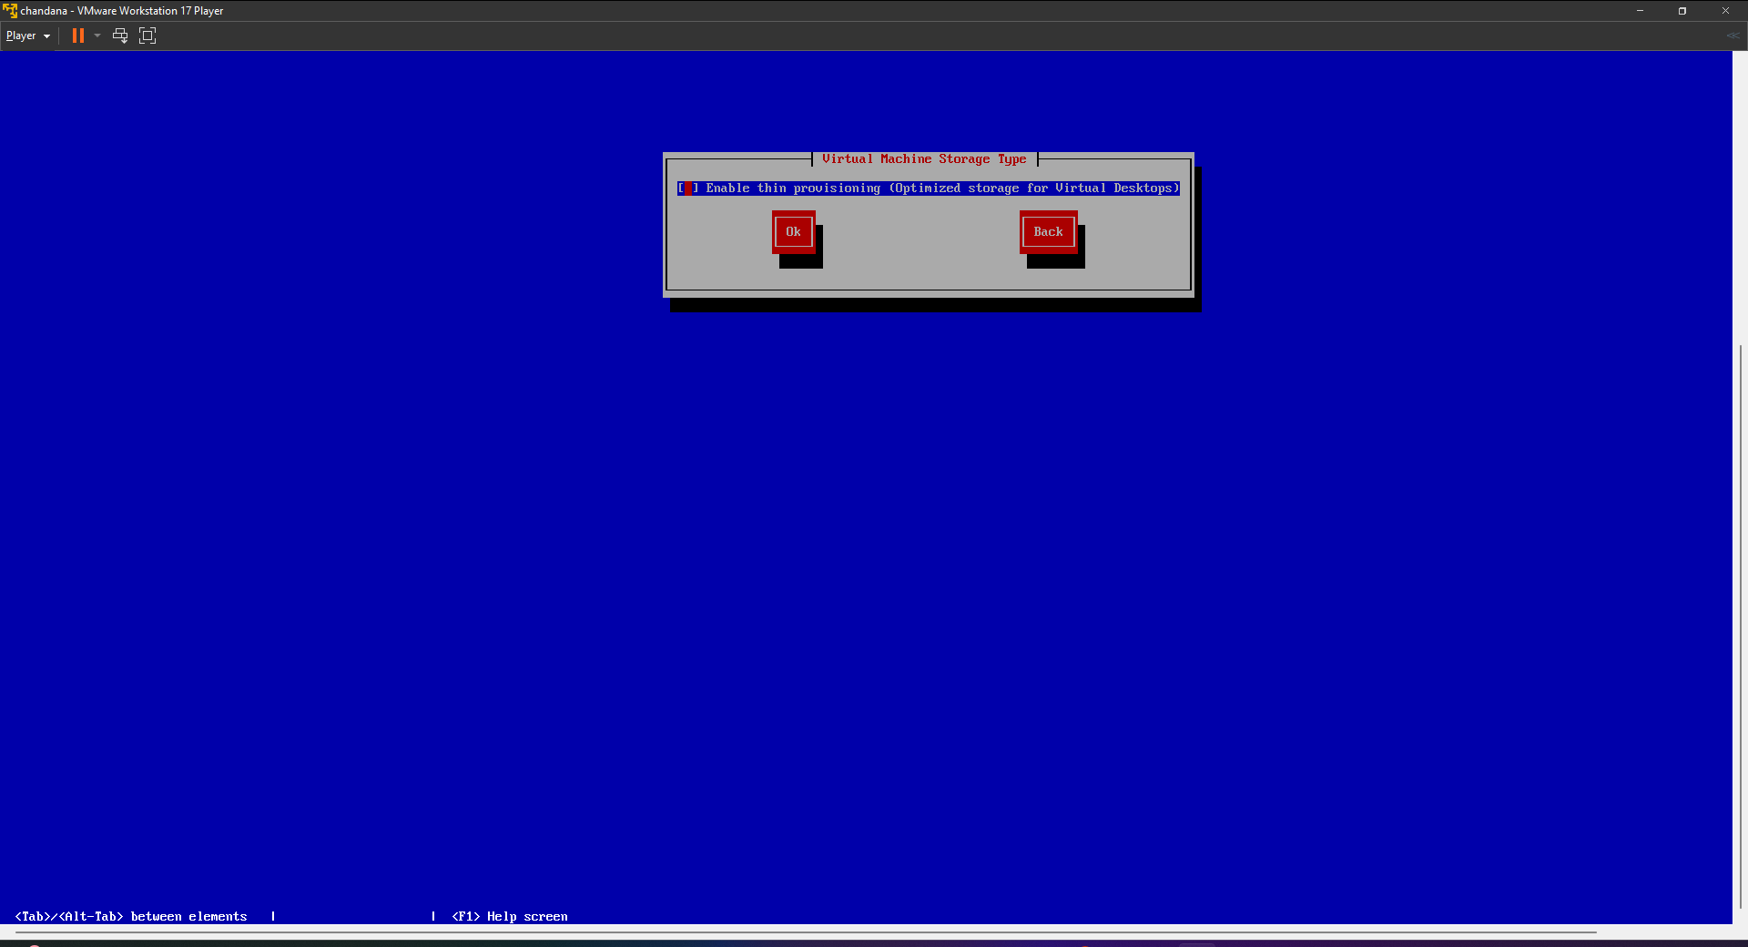

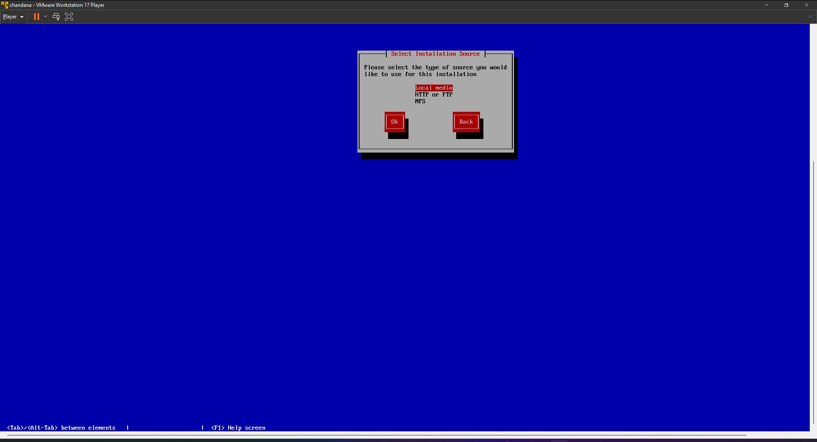

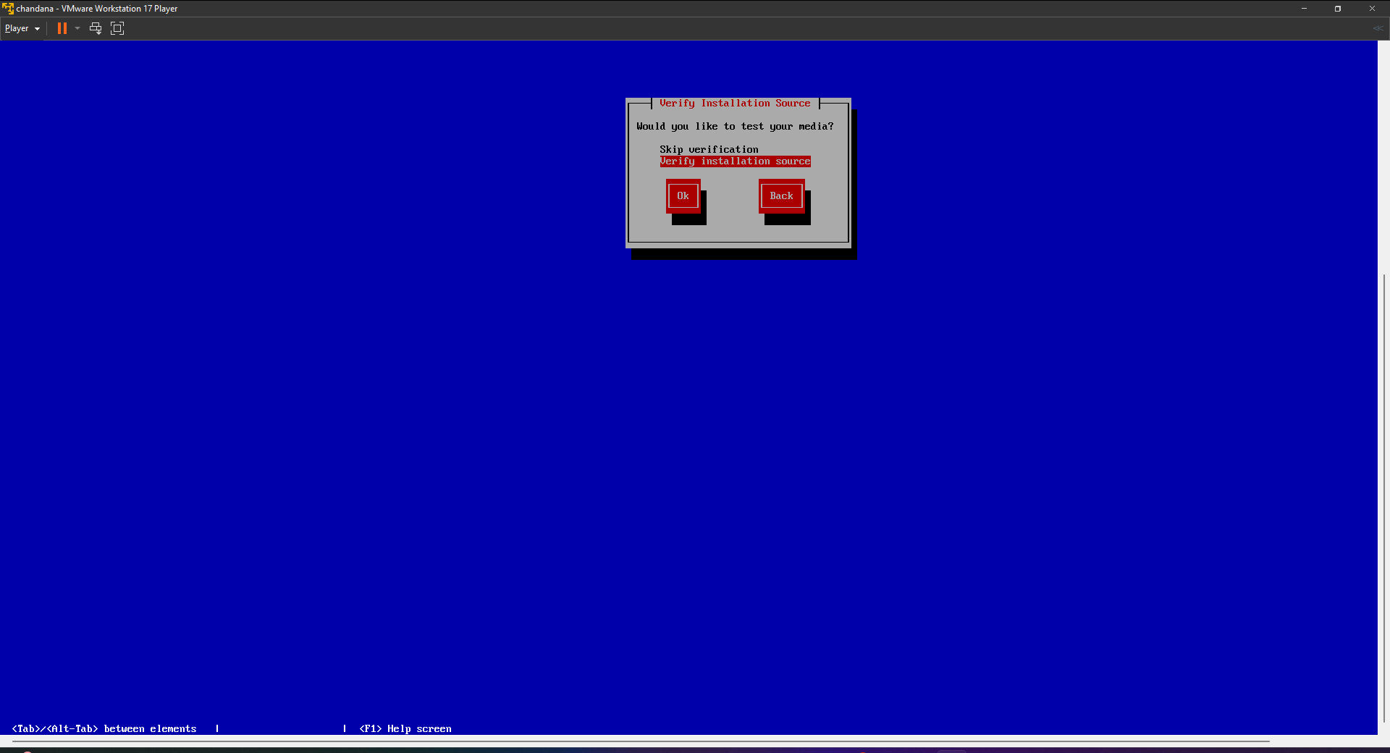

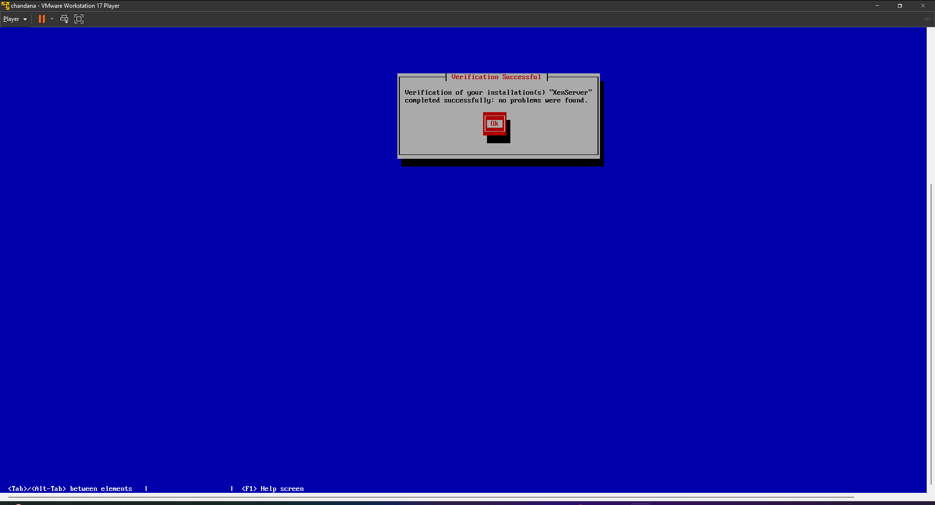

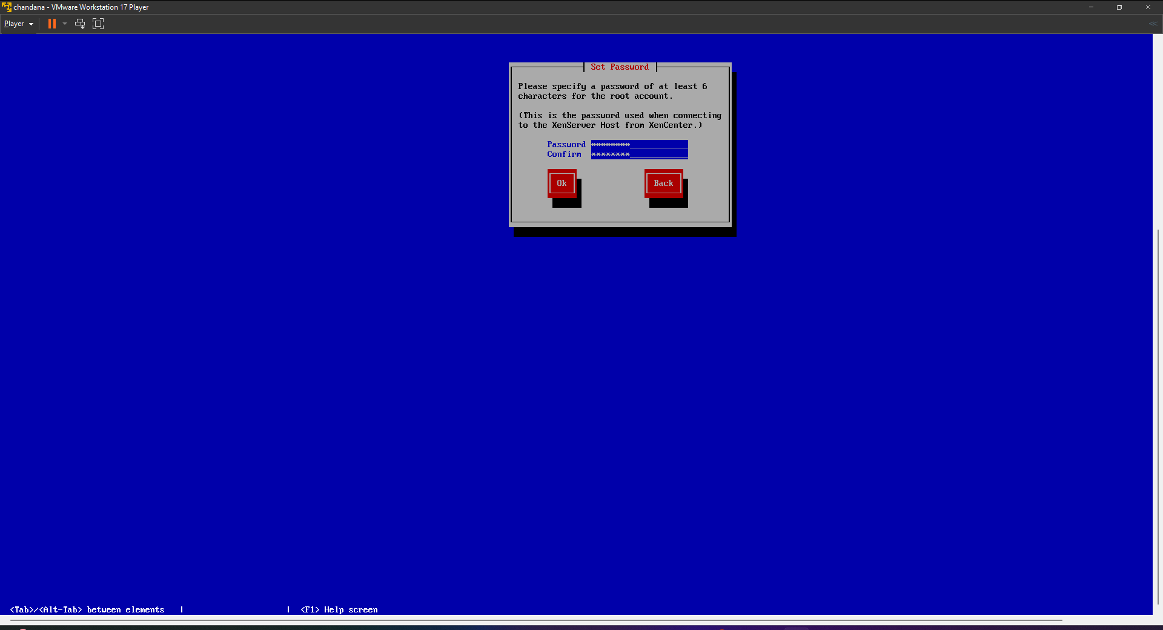

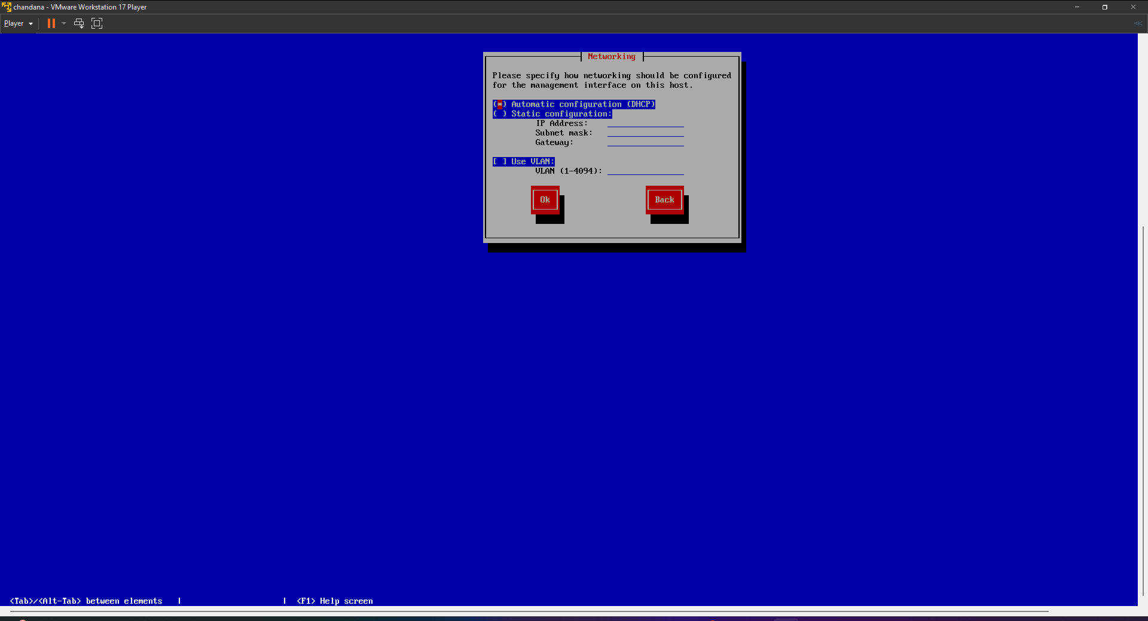

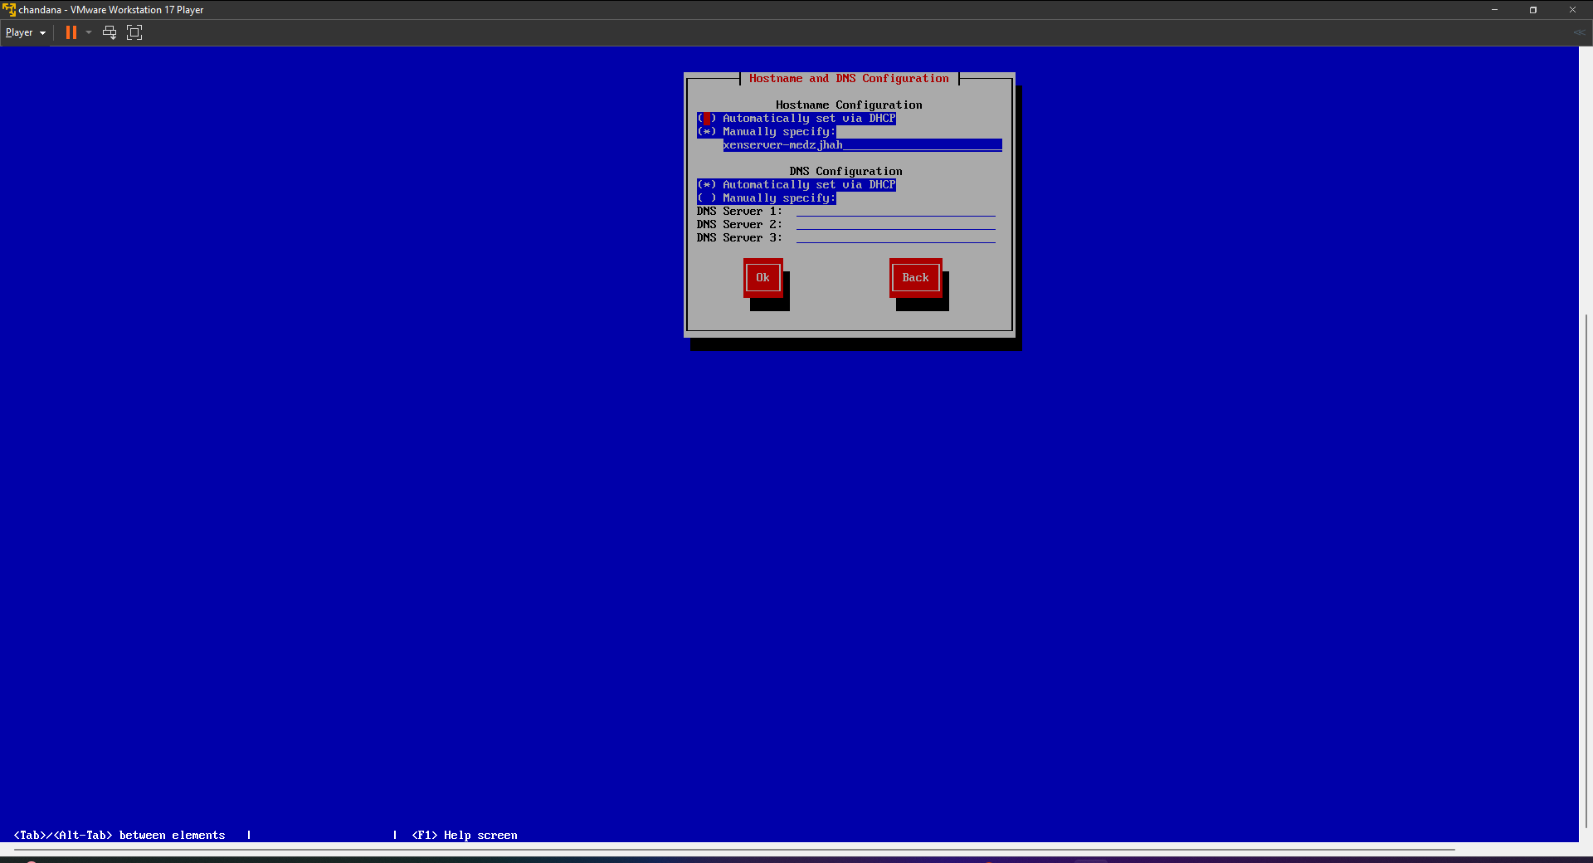

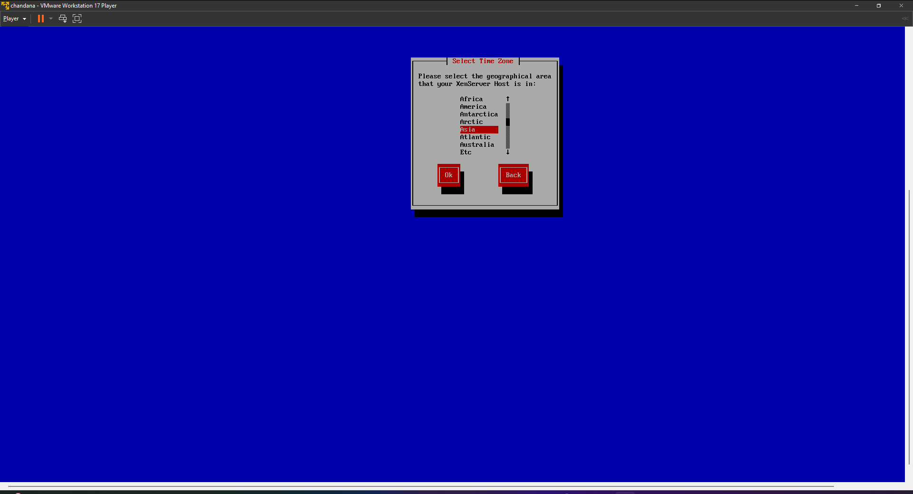

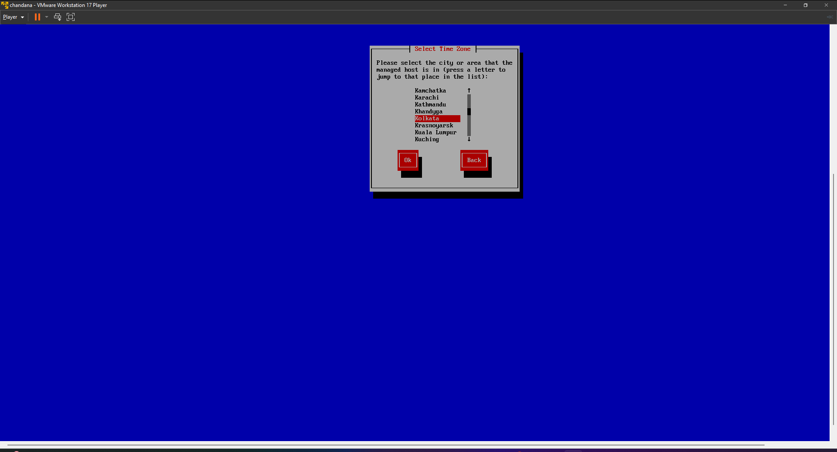

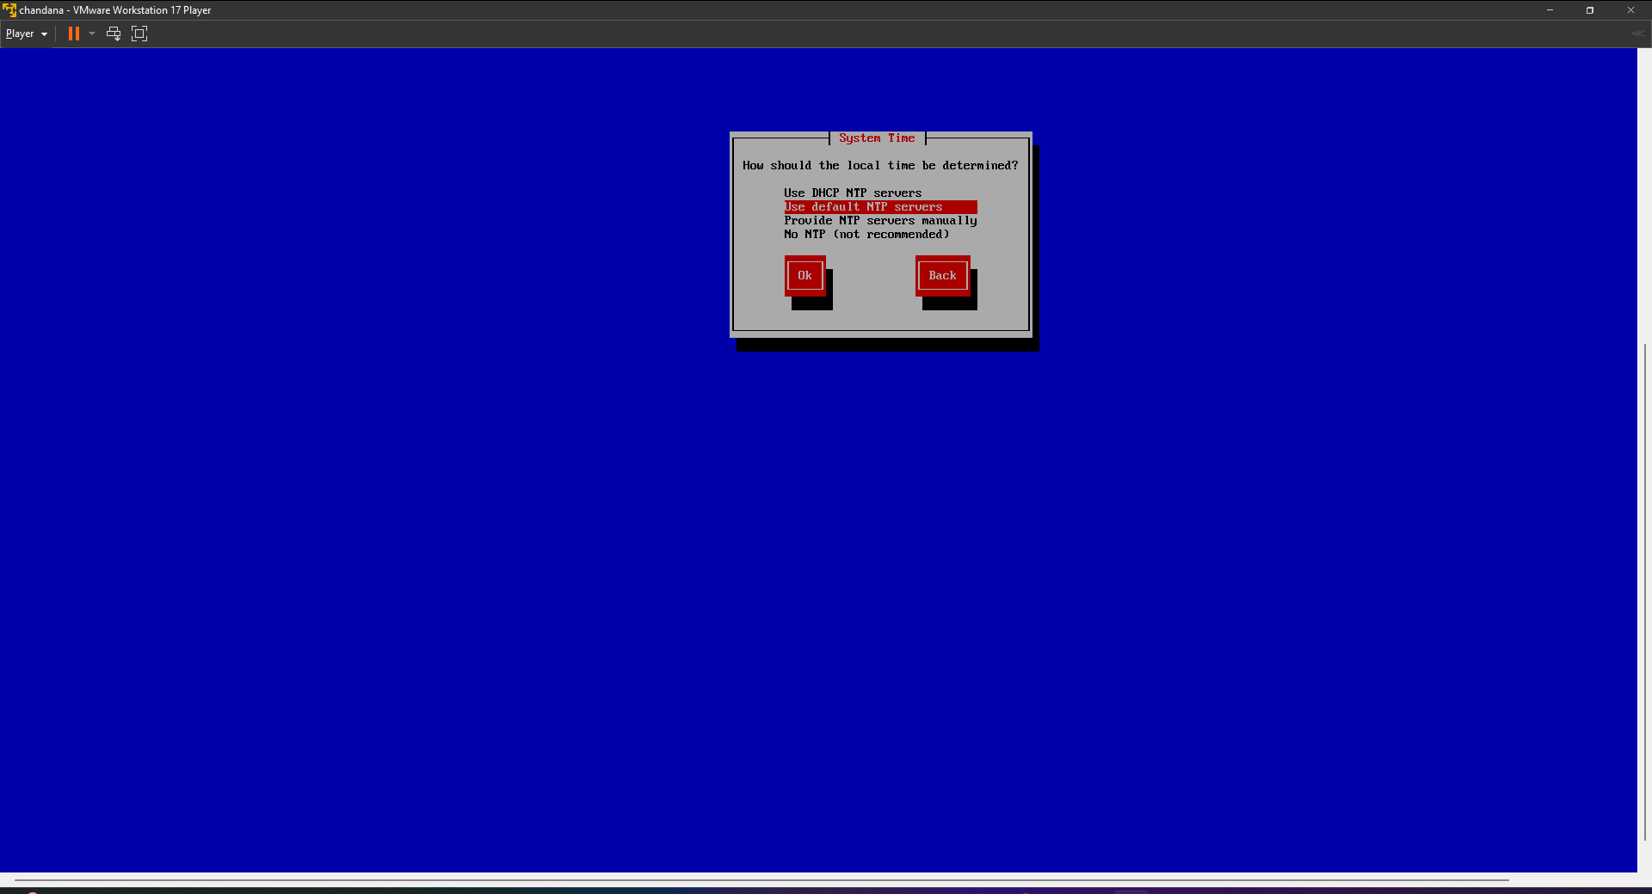

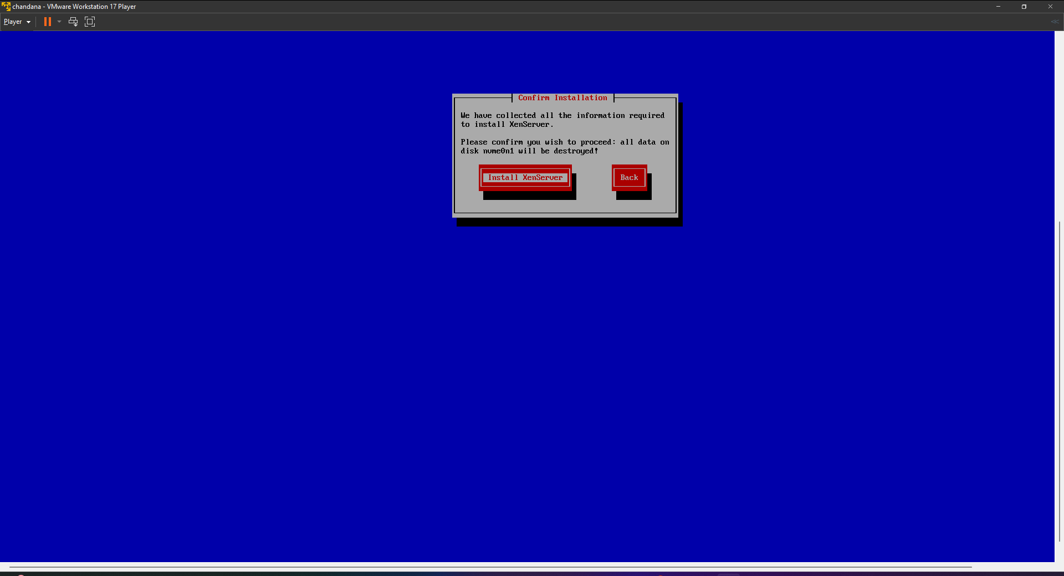

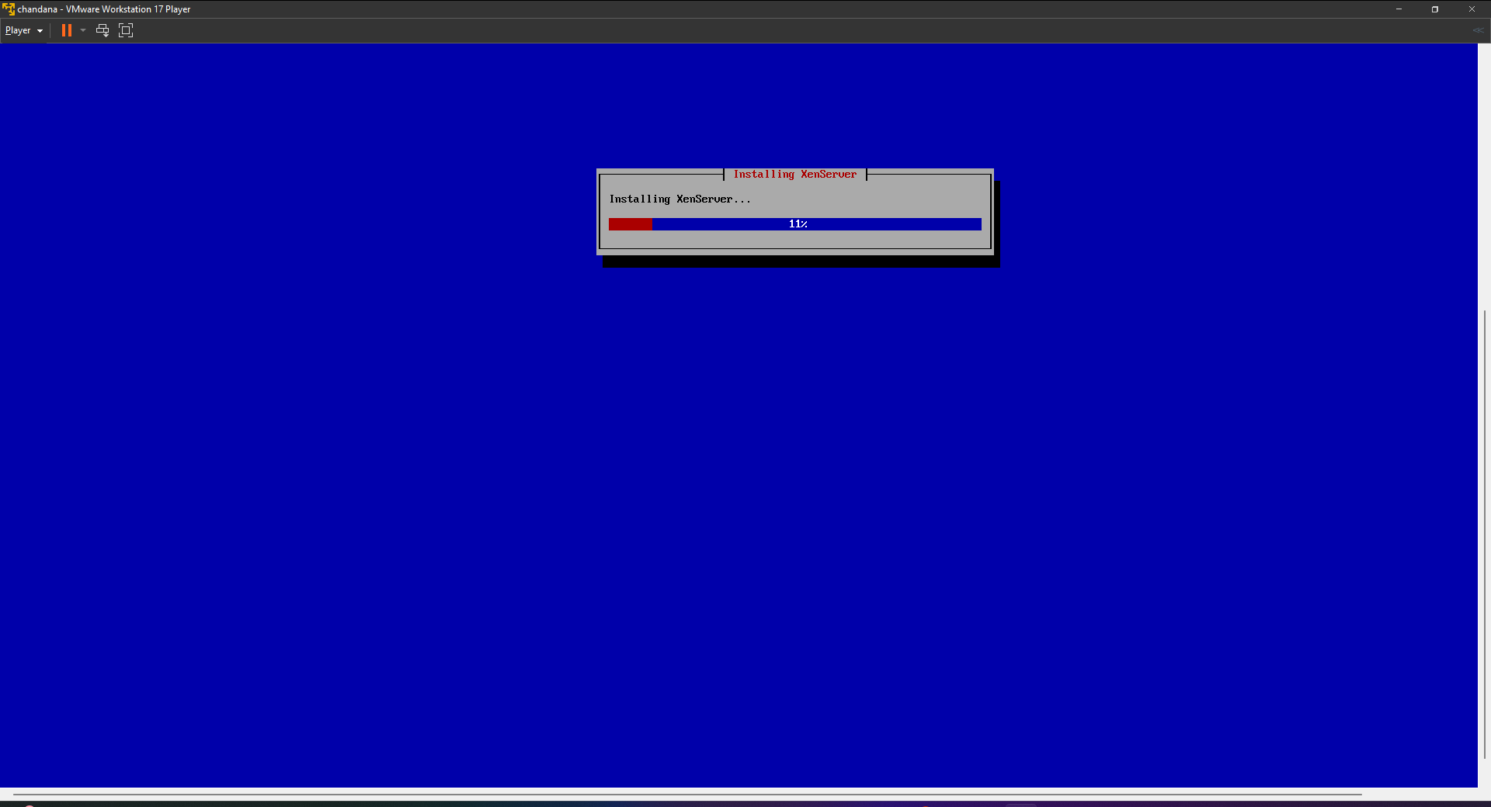

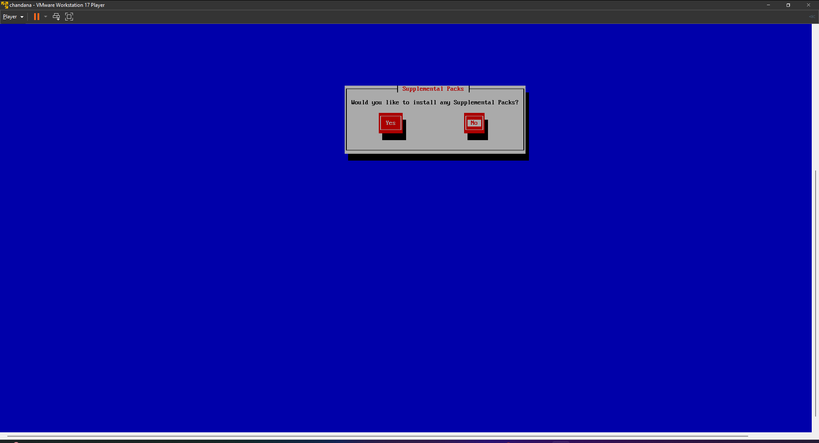

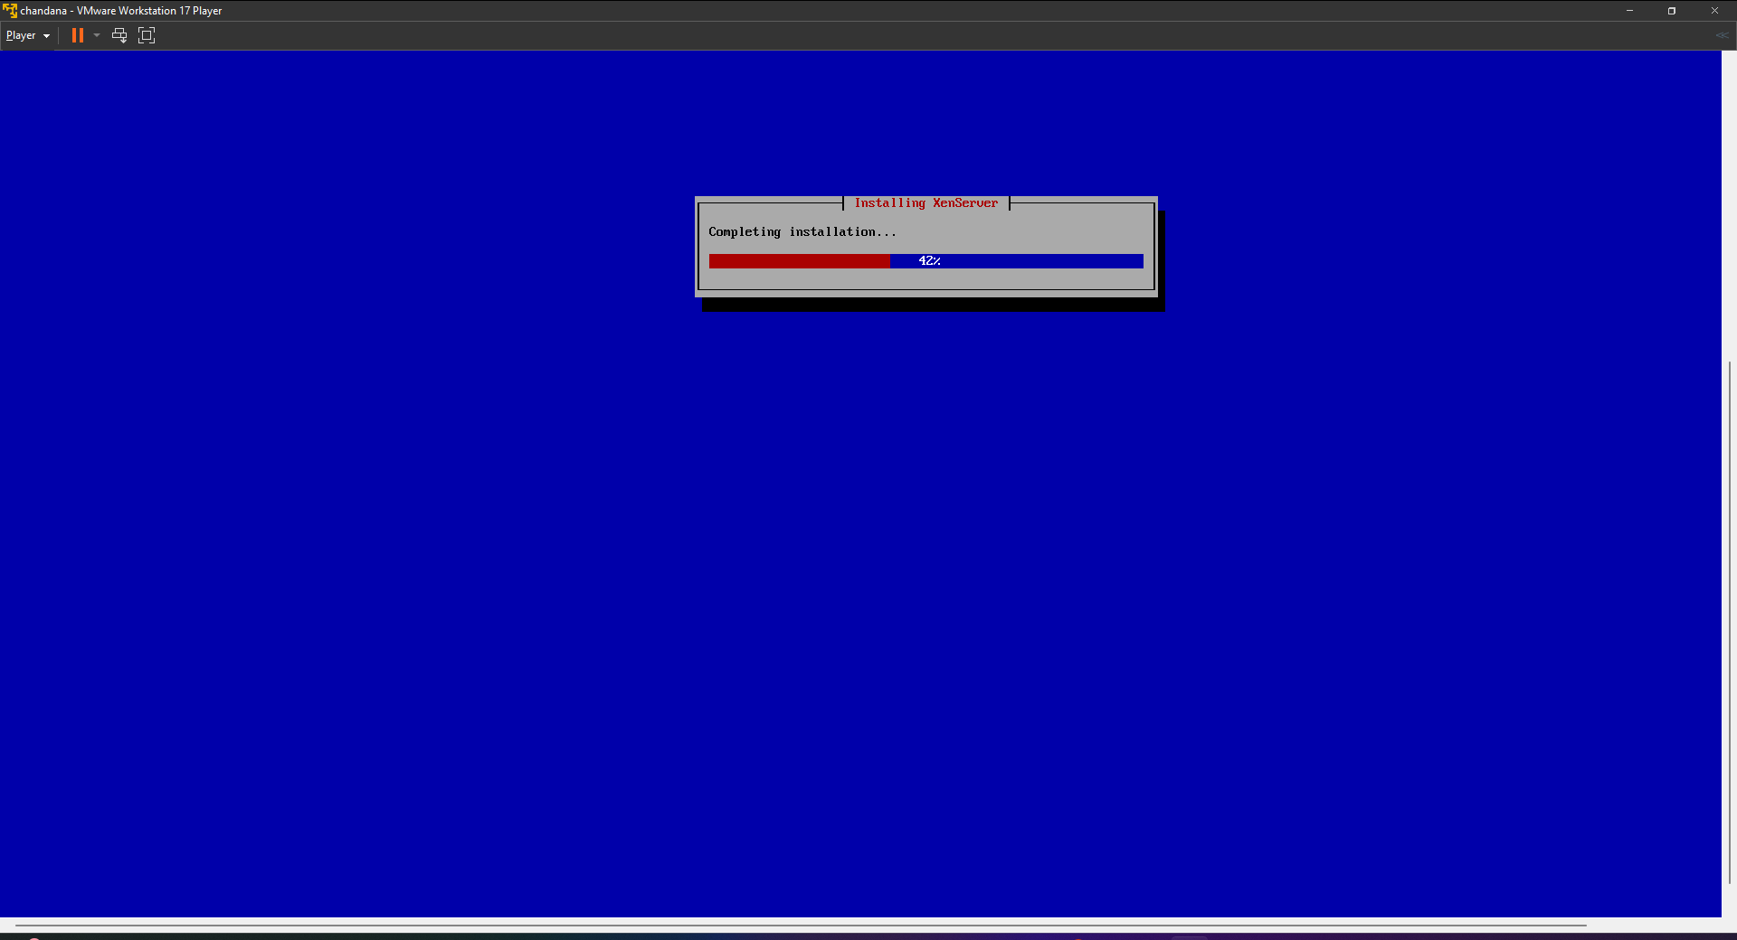

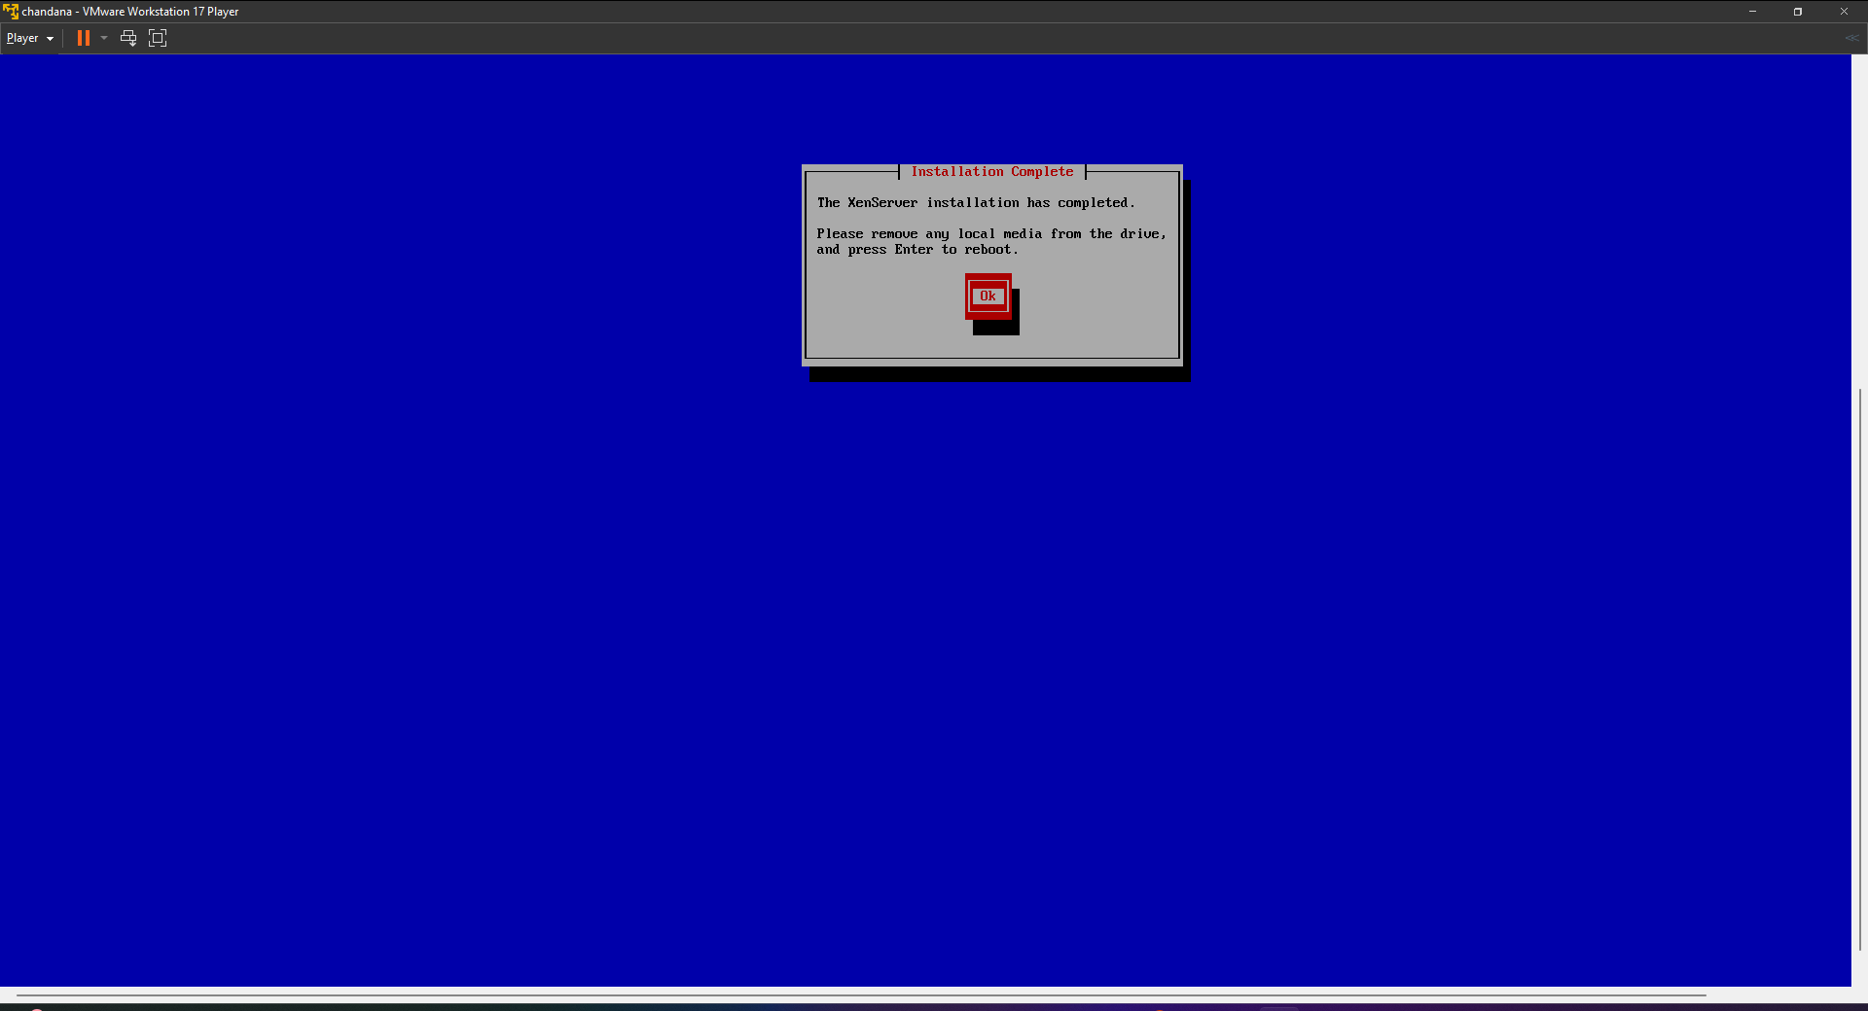

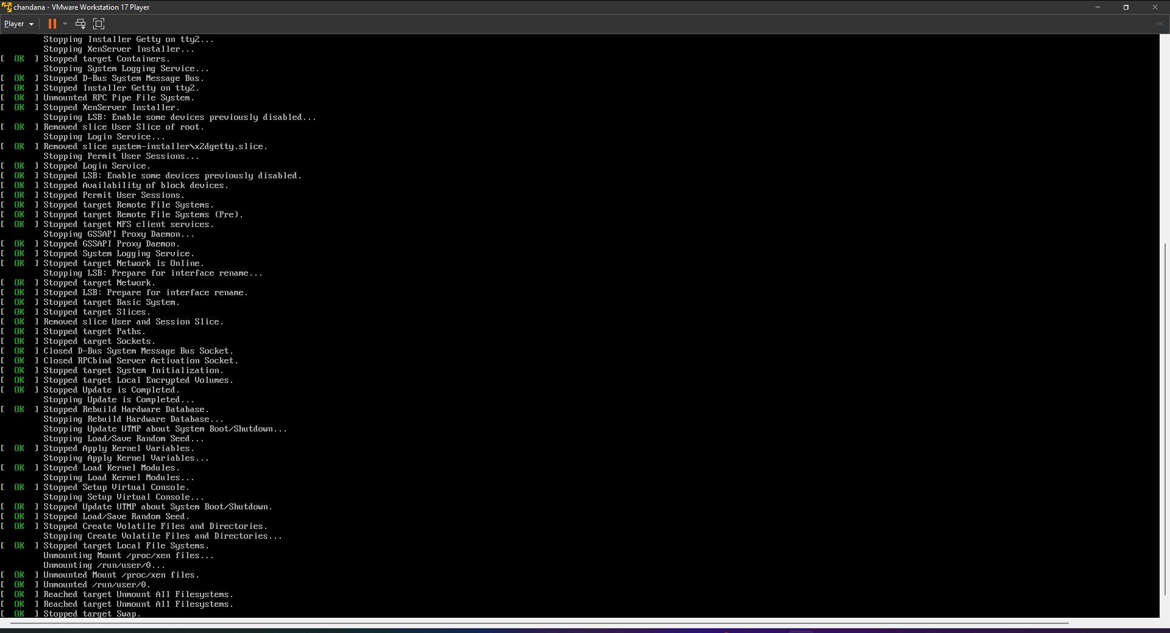

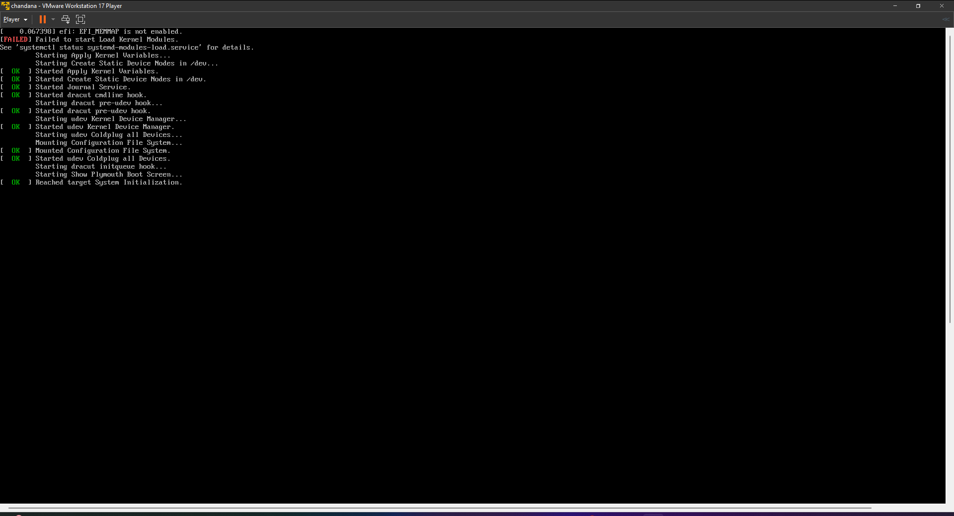

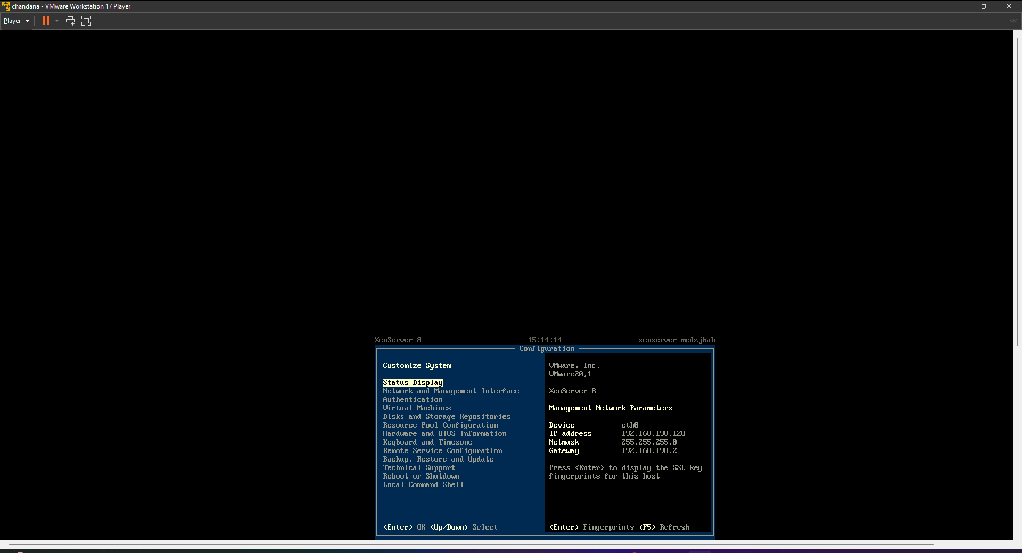

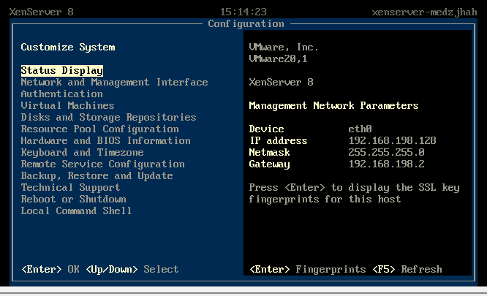

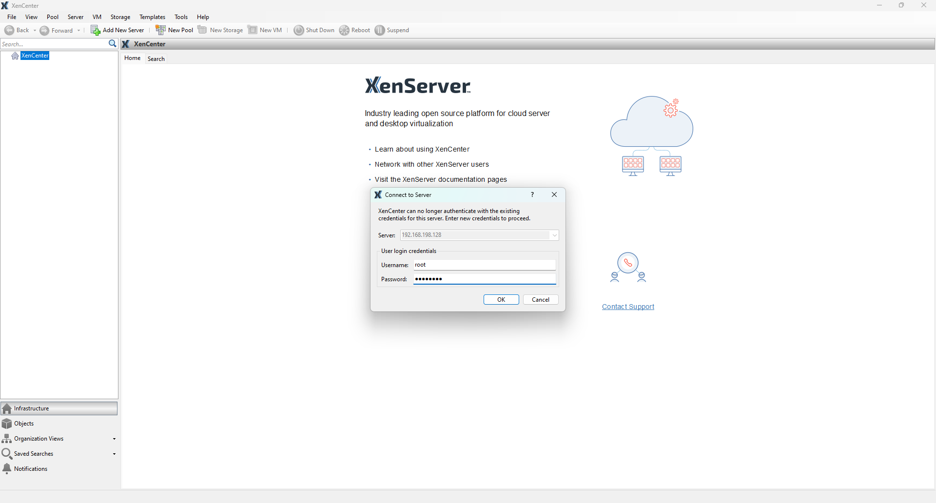

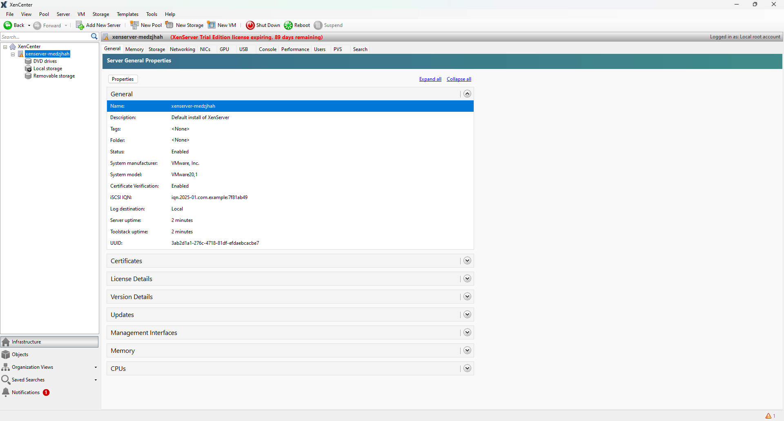

**_____________________________________________________________________________**

**Questions:**

1. On a particular server, within each virtual machine:
   1. You can run any version of Windows without regard for the version(s) running in the other virtual machines.
   2. The versions of Windows must be no more than one release level apart
   3. The versions of Windows must be exactly the same.

**Ans: You can run any version of Windows without regard for the version(s) running**

**in the other virtual machines.**

1. On a particular server:
   1. If you need to reboot one virtual machine, you have to first reboot the physical server, the individual virtual machines and then reboot automatically when the physical-machine reboot is finished.
   2. If you reboot one virtual machine, all the other virtual machines reboot at the same time.
   3. You can reboot a virtual machine without it having any effect on the other virtual machines.

**Ans: You can run any version of Windows without regard for the version(s) running**

**in the other virtual machines.**

1. When choosing which applications or databases to place on one physical machine (using a virtual machine for each application), it is best to:
   1. Choose a mixture of applications and databases with different workloads.
   2. Keep all the heavy-workload applications/databases together and all the light- workload applications and databases together.

**Ans: Choose a mixture of applications and databases with different workloads.**

1. Introduction of server virtualization in a data center:
   1. Will make the introduction of Storage –Area Network (SAN) absolutely necessary.
   2. Will make the introduction of Storage –Area Network (SAN) desirable.
   3. Will not materially change storage requirements.

**Ans: Will make the introduction of Storage –Area Network (SAN) desirable.**

1. In a virtualized- server environment, compared with a traditional server environment:
   1. It is easier to keep track of software licensing.
   2. Tracking software licensing is neither materially easier or harder.
   3. It is significantly harder to keep track of software licensing.

**Ans: Tracking software licensing is neither materially easier or harder.**

1. The VM Kernel can't boot it by itself, so it takes the help of the 3rd party operating system.
   1. True
   2. False

**Ans: False**

1. The hypervisor acts like a traffic cop, directing hardware access and coordinating requests from the guest operating systems.
   1. True
   2. False

**Ans: True**

1. XEN hypervisor does not support VM migration.
   1. True
   2. False

**Ans: False**

1. XEN hypervisor works on multiple cloud platforms.
   1. True
   2. False

**Ans: True**

**_____________________________________________________________________________**

**_____________________________________________________________________________**

**Outcomes: CO1 – Understand Virtualization.**

**_____________________________________________________________________________**

**Conclusion: (Conclusion to be based on the objectives and outcomes achieved)**

Through this experiment, the objectives of understanding virtualization and its implementation using VMware Workstation and Xen hypervisor were achieved. The concept of virtualization was demonstrated by successfully installing and running multiple virtual machines on a single physical host, showcasing the benefits such as resource optimization, reduced operational costs, and ease of management. Additionally, the understanding of Xen architecture, including domain management and virtualization types (paravirtualization and full virtualization), was deepened. This practical exercise provided hands-on experience in setting up a virtualized environment, fulfilling the learning outcomes effectively.

**_____________________________________________________________________________**

**Grade: AA / AB / BB / BC / CC / CD / DD**

**Signature of faculty in-charge with date**

**_____________________________________________________________________________**

**References:**

**Websites:**

1. <http://www.vmware.com/in>
2. [http://www.xenproject.org](http://www.xenproject.org/)

**_____________________________________________________________________________**